**Precision Mold manufacturing for electronic components**

# Introduction

The electronics industry is one of the biggest industrial sectors in the market with the broadest application ranges. And, the electronic industry requires the production of high-quality and reliable electronic components. These components are essential for the functionality and performance of various electronic devices that we use in our daily lives like smartphones, computers, medical devices, etc. So, there has also been the need for precision mold manufacturing to produce parts with a high degree of accuracy and consistency to create micro and nanoscale features on the mold surface. These features determine the shape and characteristics of the electronic components. This article covers content like the importance of precision in electronics, material selection and design consideration, precision mold manufacturing processes, and quality control standards for electronic components. This article also excavates the application and market trends of precision mold manufacturing in electronic industries.

# The Importance of Precision in Electronics

Precision is absolutely crucial in the world of electronics. Imagine electronic devices as intricate and tiny wonders. It can cause big problems if even the tiniest part isn't made with extreme precision. Precision is essential for any device to function properly. These devices do exactly what they're supposed to and fit perfectly into our modern lives when everything is manufactured super precisely So, precision in making electronics isn't just a nice to have but the very foundation that our technology-filled world is built upon. It ensures that everything runs smoothly and efficiently.

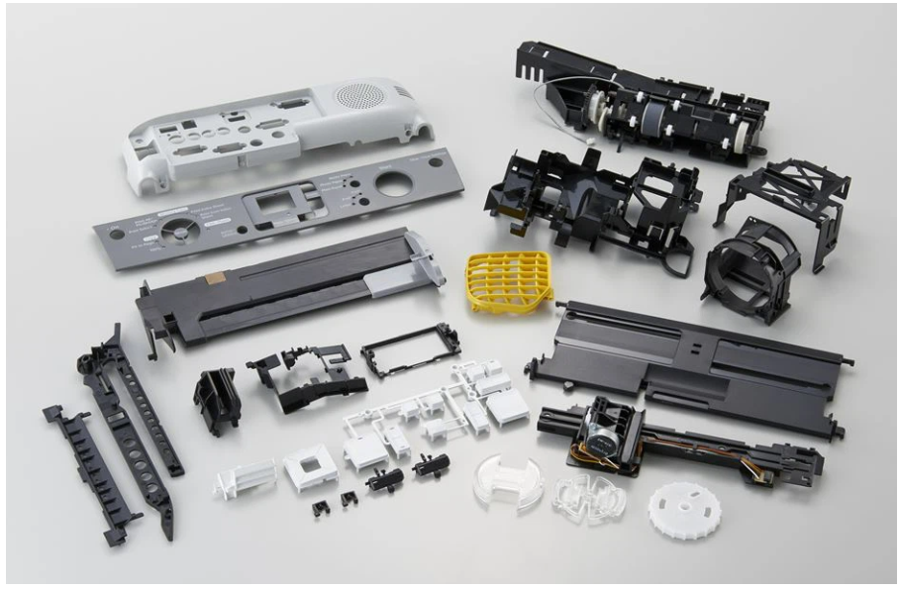

Figure 1 Precision mold manufacturing for electronics

Material selection is very crucial for precision mold manufacturing. Ordinary injection molding uses common plastic materials such as polypropylene, polyethylene, etc. However, precision injection molding needs special engineering plastics or high-performance plastics which have excellent mechanical properties, heat resistance, and chemical resistance. The following materials are commonly used materials in precision injection molding :

1. Engineering plastics:

* These plastics have excellent mechanical properties, thermal stability, and chemical resistance making them appropriate for precision molding.
* Some of the common engineering plastics being used are polyamide, polyester (PET, PBT), polycarbonate, polyimide, etc.

1. Thermoplastic Elastomer (TPE):

* It is a recyclable elastomer material with good elasticity, softness, and wear resistance.
* Common TPE materials include Thermoplastic polyurethane (TPU), thermoplastic elastomer blend (TPE-V), etc.

1. Polypropylene (PP):

* These plastics have good toughness, chemical stability, and heat resistance.
* especially suitable for manufacturing containers and pipelines.

1. Polystyrene (PS):

* They are transparent or semi-transparent plastic materials with good toughness and insulation properties.
* These are the most used plastics in electronic product casings and optical components.

1. Polycarbonate (PETG):

* transparent and impact-resistant plastic material with good toughness and chemical stability.
* Used in the manufacturing of bottles, packaging boxes, medical devices, etc.

1. Polyurethane (PU):

* It is a plastic material with elasticity and wear resistance
* commonly used in the manufacturing of seals, gaskets, car seats, etc.

1. Polytetrafluoroethylene (PTFE):

* excellent high-temperature resistance
* low friction coefficient
* excellent insulation performance.
* commonly used for manufacturing seals, valve gaskets, cable insulation layers, etc.

When selecting a plastic, the intended use must be considered. For electrical wiring projects, a flexible and chemical-resistant plastic is ideal due to its versatility. Some products require lightweight plastics – phones for example. The appliance's functionality is protected by plastic polymers that provide heat and electrical insulation. Plastic casings can keep electric currents safely contained within a device making it run more efficiently and protecting the consumer from the risk of electric shock. Plastics are poor heat conductors but some manufacturers make them fire-resistant for added safety. Also, plastics with lower shrinkage rates are chosen for parts to be more precise.

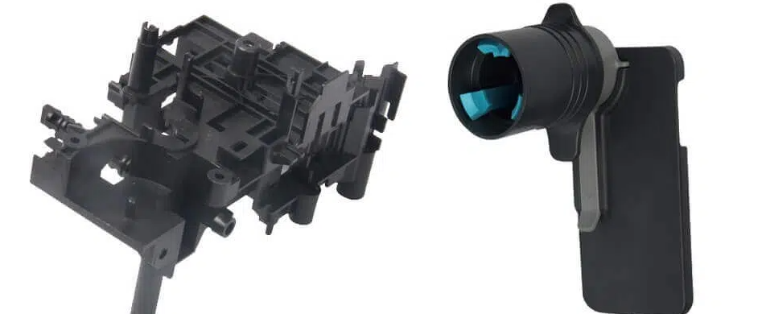

Figure 2 ABS precision injection molded

# Precision Mold Manufacturing Process

Precision mold manufacturing involves creating molds or dies that are used for the mass production of electronic components like connectors, microchips, and other intricate parts. The precision of the molds directly impacts the product’s quality and performance. Here is a breakdown of the key steps in precision mold manufacturing:

* **Designing and Prototyping:** The first process begins with the design phase where engineers use Computer-Aided Design (CAD) software to create 3D models of the mold. This design phase takes all the necessary considerations for the specifications of the electronic component to be produced. Then, a prototype is created to verify its functionality and suitability.

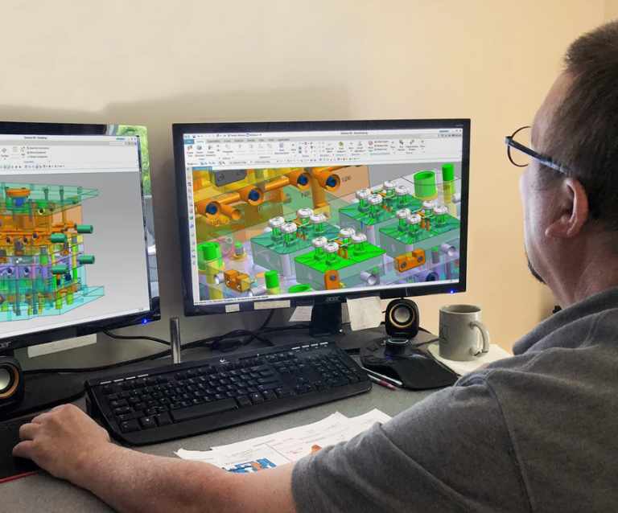

Figure 3 CAD design of molds (source:https://www.mmsonline.com/articles/cadcam-software-brings-process-automation-for-mold-design-machining)

* **Material Selection:** Material selection is crucial for precision molding. Thermal conductivity, dimensional stability, and wear resistance must be considered during the selection of materials. Some of the common choices for materials depending upon applications are steel, aluminum, and various alloys.

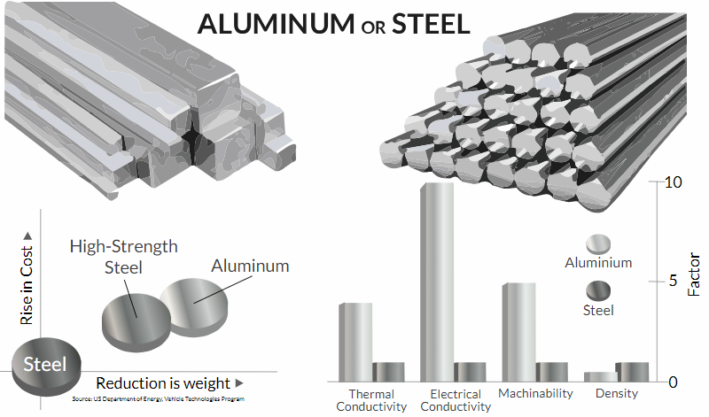

Figure 4 Aluminium vs Steel (source:https://www.erectastep.com/aluminum-steel-metal-better/)

* **Precision Machining:** Precision machining is the core for the mold manufacturing process. CNC machines are used to precisely shape the mold according to the CAD design. This step demands highly skilled machinists and state-of-the-art equipment to achieve tight tolerances and surface finishes.

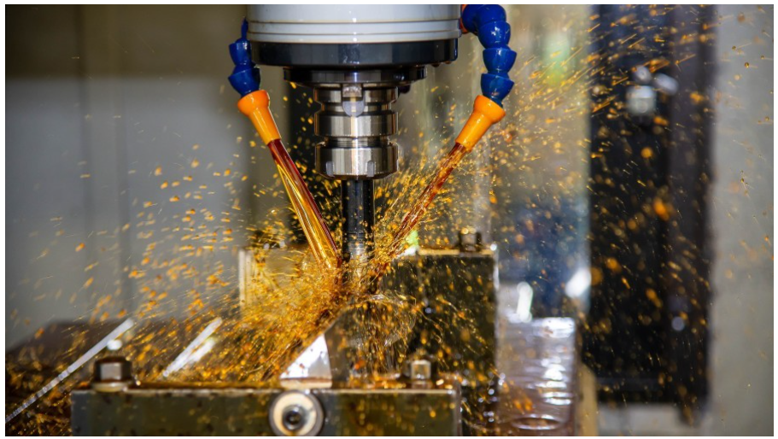

Figure 5 Precision machining for the mold (source:www.linkedin.com/pulse/unveiling-secrets-precision-machining-mold-manufacturers-suvi-wu/)

* **Heat Treatment:** Heat treatment processes like quenching and tempering are used to enhance the hardness and durability of the mold. This step makes sure that the mold can withstand the high-pressure during injection molding.
* **Surface Finish:** The mold's surface finish is crucial for any high-quality molded components. It impacts the release of the molded parts and prevents defects like flash. So, the processes like polishing and texturing the mold surfaces are done with extreme precision.

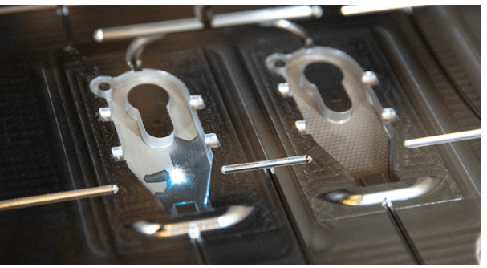

Figure 6 Mold tech texture being applied in mold (source:https://www.protolabs.com/resources/design-tips/mold-texture-standards-and-finishes/)

* **Assembly and Quality Control:** The mold components are then assembled and quality control checks are conducted to ensure the mold's accuracy and reliability. Dimensional tolerances and surfaces are verified by the quality assurance department in this step.

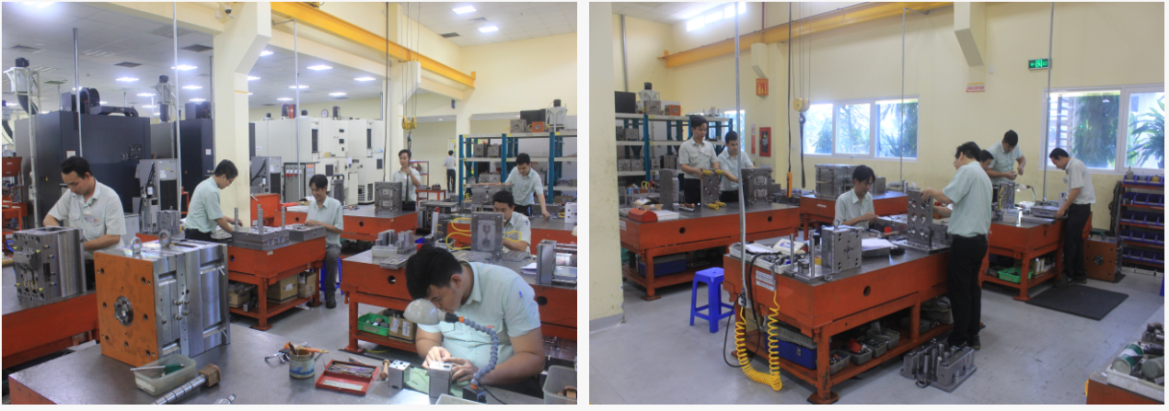

Figure 7 Assembly line of midamold's precision molds (source: https://www.midamold.com/quality/assembly-line)

## Technological Advancements and Innovations:

Precision mold manufacturing has benefited from several technological advancements and innovations over many years:

* **CAD/CAM Integration:** The use of CAD (Computer-Aided Design) and CAM (Computer-Aided Manufacturing) systems has brought huge changes in precision manufacturing. This helps in automation in the designing and manufacturing of the molds. It enables greater precision and efficiency.

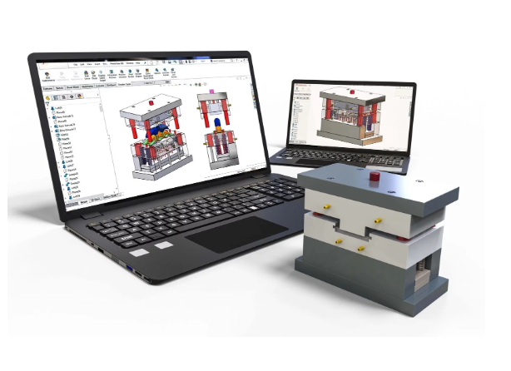

Figure 8 CAD/CAM for mold design and manufacturing (source:https://www.cavitymold.com/engineering/)

* **High-Speed Machining:** CNC machining has become more advanced and these high-speed machining techniques have reduced production times while maintaining high accuracy for the molds.

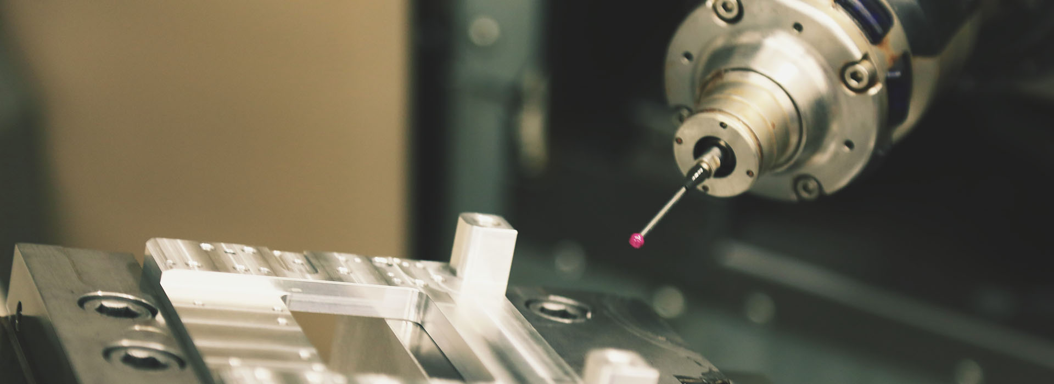

Figure 9 high speed machining for precision molds (source:https://witmold.com/high-precision-molds/)

* **3D Printing:** Additive manufacturing technologies like 3D printing have accelerated prototyping for product developers by creating rapid tooling for molds. 3D printing has reduced the mold production time drastically as the most cost effectiveness option.

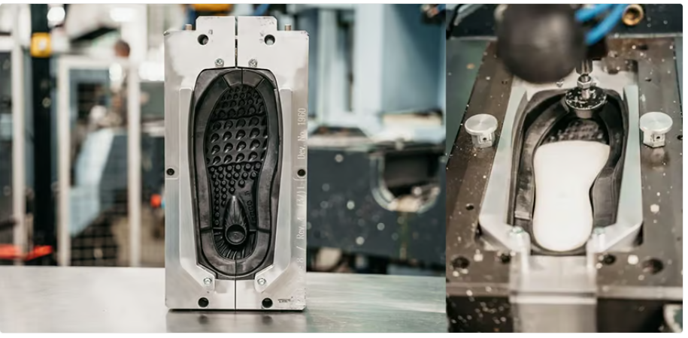

Figure 10 ECCO spent years perfecting its solution for 3D printed shoe sole molds using Stratasys 3D printers.(source:https://all3dp.com/1/3d-printing-injection-molds-the-ultimate-guide/)

* **CAE Simulation Software:** There are various computer-aided engineering software that are available today. This software allows engineers to simulate the mold flow. Mold flow simulation software helps in optimizing the mold design predicting potential issues and reducing the number of design iterations. Some of the software that performs mold flow simulation are Moldflow, SolidWorks, Autodesk Mold Flow, Moldex 3D, etc.

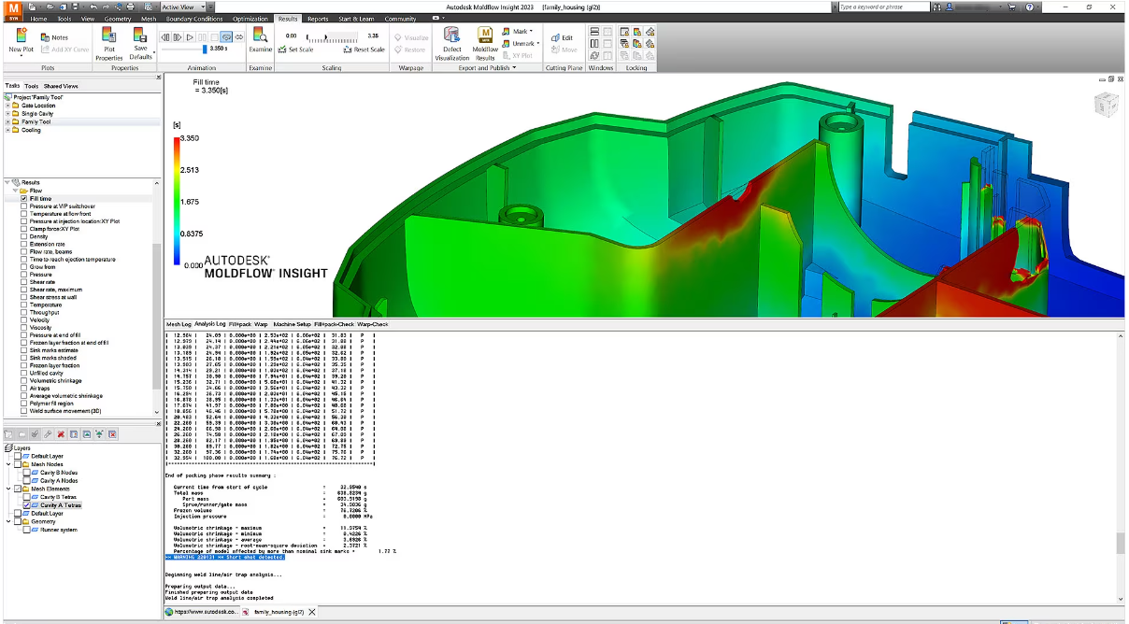

Figure 11 Autodesk Moldflow simulation interface

## Challenges and Solutions:

Precision mold manufacturing comes with several challenges. Some of the major challenges are listed below with their solutions:

* **Tight tolerances:**
* Tight tolerances can be achieved with precise machining.
* meticulous inspection should be done.
* proper quality control processes should be employed.
* **Thermal expansion:**
* designing molds with materials having low coefficients of thermal expansion.
* carefully controlling the temperature during molding.
* **The durability of molds:**
* Proper maintenance is a must.
* regular cleaning and repairs of precision molds should be done.
* High-quality materials and heat treatment processes for durability.

# Design Considerations for Electronic Components

The journey to a functional electronic component begins with design. The design considerations must be done at this stage for the precise mold manufacturing for electronic components.

* **Precision and tolerances:** Tight tolerances and precision are necessary for electronic components to function as intended. Designers must specify precise tolerances to ensure that components fit together seamlessly.
* **Materials selection:** The choice of materials and their properties significantly impact the design. Designers must consider the properties like conductivity, durability, and thermal stability of materials while selecting.
* **Seamless Integration:** Electronic devices consist of multiple components that are assembled together to deliver their function. So special consideration must be done while designing such that different components fit together. So, minimizing wasted space and maximizing overall system efficiency is essential. This seamless integration enhances the overall functionality and performance of the electronic device.
* **Sustainable Design:** Sustainability is a very important consideration in modern design. Precision molds contribute to sustainable designs by facilitating the use of recycled materials and minimizing waste in the manufacturing process. Eco-friendly choices are becoming integral to electronic component design.
* **Miniaturization:** Miniaturization is a defining trend in the electronics industry. Designers should be crafting small components that maintain functionality and reliability even as devices shrink in size. Creating precision molds ensures accuracy in tiny components.
* **Quality Control and Reliability:** Achieving tight tolerances requires the use of precision molds but the design of the product itself also plays a vital role in quality control. A well-planned design can help minimize the risk of defects. It also simplifies the manufacturing process and prevents product failures. It is essential to maintain strict quality control standards to ensure the integrity of the components.
* **Customization for Diverse Applications:** Electronic components often serve a wide range of applications. Designers should keep flexibility in mind allowing for customization to meet the specific requirements of different use cases. This adaptability ensures that components are versatile and can excel in diverse scenarios.

# Quality Control and Standards in Mold Manufacturing

Quality control is vital in electronic mold manufacturing to prevent failures and maintain component reliability. Quality control serves as the guardian ensuring molds are crafted to exacting specifications. Why? Because these molds shape the destiny of electronic components. Even the slightest error can lead to significant issues in the final product.

## The Importance of Quality Control:

* **Early Detection of failure:** Quality control is a proactive measure that prevents issues during manufacturing which could lead to delays and ill-fitting parts at an early stage. Otherwise, these ill-fitting parts may cost a huge amount later.
* **Ensuring Longevity:** Quality control preserves molds by identifying and addressing wear and tear in time ensuring efficient and uninterrupted manufacturing.
* **Cost savings:** Quality control minimizes expenses by addressing issues in mold manufacturing saving time and resources.

## Quality Control Process in Precision Mold Manufacturing

* **Design Verification:** The process begins with a proper examination of the mold design to ensure it accommodates desired features and functions.
* **Material Inspection:** Raw materials undergo many checks for consistency and mechanical properties.
* **Machining and Fabrication:** Inspections are done to ensure dimensional accuracy, surface finish, and alignment during machining and fabrication.
* **Mold Trials:** Pre-production testing is done to check material flow, cooling, filling, and part ejection.
* **In-Process Inspections:** Regular checks are done to maintain quality standards during manufacturing.
* **Post-Production Evaluation:** A final assessment is done to confirm overall quality, dimensional accuracy, and compatibility with plastic materials for production.

# Applications and Market Trends

Precision-manufactured components have diverse applications in various electronic devices, such as:

* **Smartphones:** Smartphones utilize various precision-manufactured components such as cameras, microphones, speakers, sensors, antennas, etc. These precise components are the reason for making it possible to use features like photography, video recording, voice recognition, face recognition, and wireless communication.
* **Laptops:** Laptops have many precision-manufactured integrated components including keyboards, touchpads, screens, batteries, and fans.
* **Medical equipment:** Some electronic medical equipment is made with a fusion of components such as electrodes, pumps, valves, and catheters for various purposes. These components are the factors for successful diagnosis and treatment.
* **Automotive:** Automotive uses precision-manufactured components such as sensors, actuators, switches, relays, etc.

The market for precision mold manufacturing for electronics is growing steadily and is expected to expand even more broadly in the future. Some of the factors driving the market growth are:

* **Increasing demand for electronics:** The demand for electronic devices is increasing due to technological advancement, innovation, and digitalization. This creates a need for more electronic components with higher precision and quality.
* **The increasing complexity of components:** The complexity of electronic components is increasing due to various factors such as miniaturization. Smaller and more reliable components are in demand these days. This creates the need for precise mold which is difficult to achieve with other conventional methods. So, precision mold manufacturing is needed more in the future with growing complexity and decreasing sizes.
* **Increasing competition and customer expectations:** The competition and customer expectations in the electronics industry are growing rapidly. This creates a need for more efficient and effective mold manufacturing processes and practices that can deliver quality parts in a short time.

# Advanced Technologies in Precision Mold Manufacturing

Precision mold manufacturing is constantly evolving and improving with the use of advanced technologies. These technologies play a crucial role in the enhancement of manufacturing efficiency, quality, and productivity. Some examples of advanced technologies in precision mold manufacturing are:

1. **Artificial intelligence:** Artificial intelligence is very popular these dayswith its evolution. The manufacturing industries are also making full use of it with its growing popularity. The injection molding industry is experiencing a transformation with AI. AI technologies are being utilized for predictive maintenance, quality control, process optimization, and material optimization. Intelligent sensors collect data on variables like temperature, pressure, and flow rate. This sensor allows algorithms to identify patterns and potential issues which leads to more efficient and precise manufacturing processes. Their ability to detect and correct defects is also what makes them a superior choice. Manufacturers can rely on AI for higher-quality products and optimized production. AI's role in injection molding is expected to evolve even further enhancing the industry.

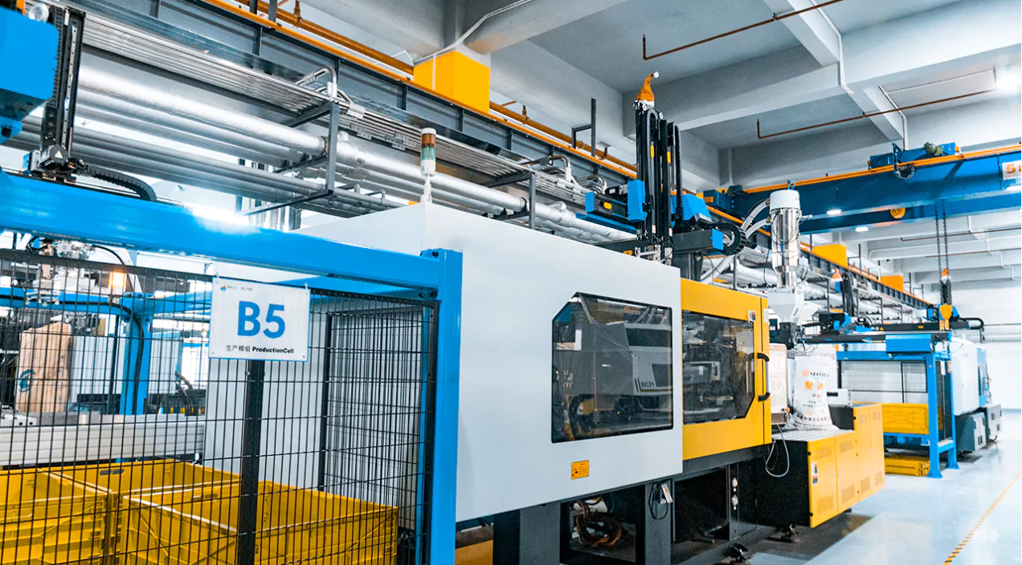

Figure 12 AI-assisted injection molding (source:https://prototool.com/ai-assisted-injection-molding/)

1. **Automation:** Automation is used to automate various processes of the precision mold manufacturing process such as from material handling to mold fabrication. They are used in mold injection, compression, and component ejection. Automation can help to reduce human intervention in post-processing as well as labor costs. Also, there is no human error.

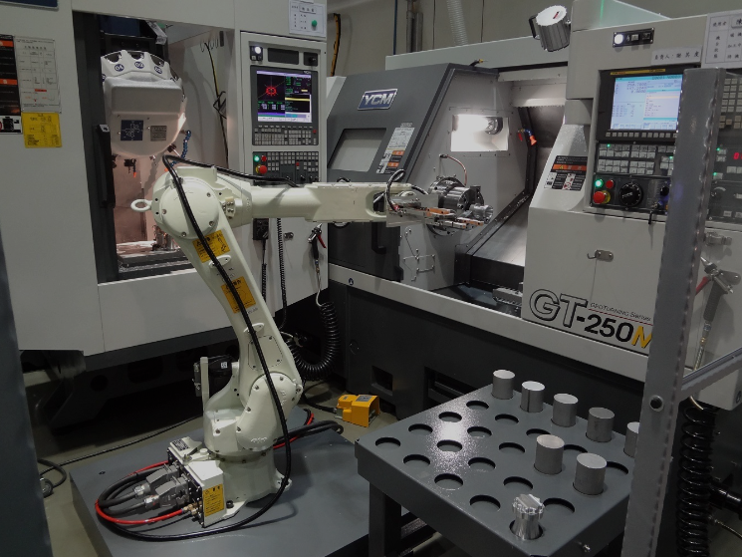

Figure 13 Industry uses CNC robot arm (source: https://topstar-china.en.made-in-china.com/product/CsaEzSkVAqWu/China-Industry-Uses-CNC-Robot-Arm.html)

1. **3D printing:** The conventional tool takes time and a huge budget while prototyping the mold. Additive manufacturing like 3D printing has become a great alternative of conventional tooling to create molds or components as it allows direct from digital models without using any molds or tools. This leads to a reduction in production time as well as a very cost-effective option. Also, 3d printing can be used for printing complex molds in a short time which is difficult with other conventional methods.

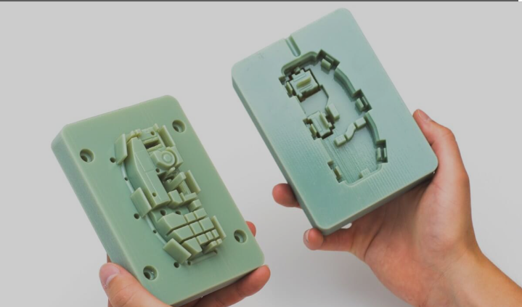

Figure 14 3d printed mold

# Conclusion

The demand for high-quality and precise electronic components will always be there. The increasing complexity of electronic devices will always require high-quality and precise parts. So, the new advanced technologies are essential for contributing to the precision of these components. Some of the advanced technologies that are being used today are AI, automation, and 3D printing as these advanced technologies can enhance efficiency and quality in the production of precise parts. It is essential to continue pushing the boundaries of precision mold manufacturing to drive progress in the growing electronics sector with evolving technologies.